# Title: On the Main page. Unlogical placement of an unlickable word “Показати” on the “Наші контакти” slide-box.

**Priority:** Medium

**Severity:** S4 Minor

**Environment:**Browser Mozilla Firefox 118.0.1 (64-bit)

Browser Chromium 117.0.5938.132

**Steps to reproduce**

1. Open the Main page: <https://oxford-med.com.ua/ua>

2. Hover a mouse over a “Наші контакти“ section

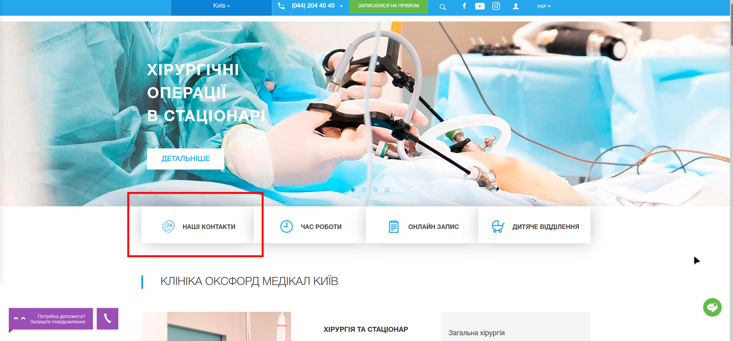

**Actual result**

Inside a slide-box, we see a clickable word “показати”, while a phone number is already displayed. So, it is difficult to understand the reason of placing this word.

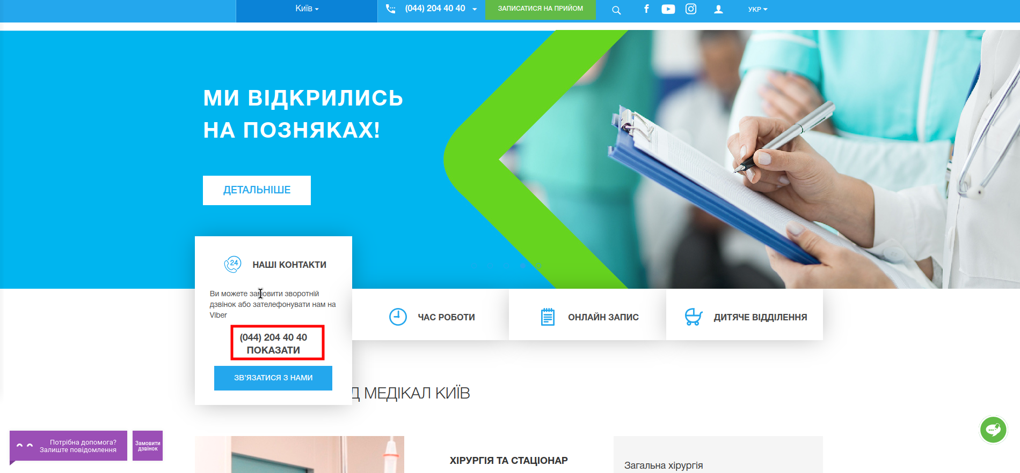

**Expected result**

According to UI-UX, all sections, blocks, and texts must have logic placement. So, the word “показати” or must be deleted, or a telephone must be hided (and clicking on the word “показати” must reveal this phone).

*Screenshot from* ***Jira****:*

